OFFICE BUILDING B
Ontario, CA

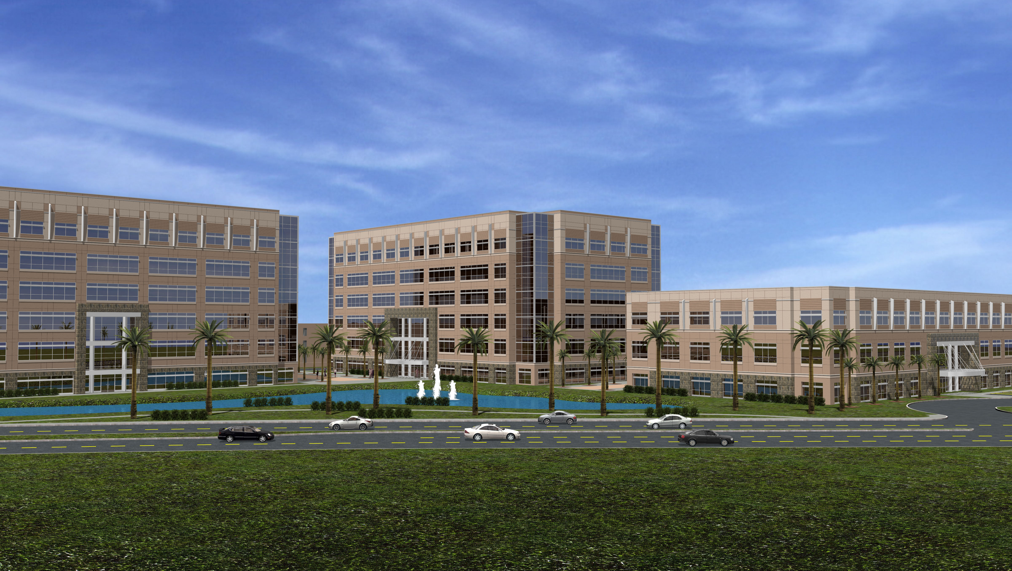

Senior Thesis
Final Report
April 12, 2007

Maggie Machinsky
Penn State University
Architectural Engineering
Structural Option
Advisor: Andres Lepage

Table of Contents

ACKNOWLEDGEMENTS................................................................................... 3
EXECUTIVE SUMMARY..................................................................................... 4
INTRODUCTION ................................................................................................. 5
PROPOSAL ........................................................................................................... 10
DEPTH ANALYSIS.................................................................................………..13
ARCHITECTURAL BREADTH..........................................................................20
CONSTRUCTION MANAGEMENT BREADTH ..........................................27
FINAL CONCLUSIONS...................................................................................... 32
REFERENCES........................................................................................................ 33
APPENDIX A......................................................................................................... 34
APPENDIX B……………………………………………………………………...36

Acknowledgements

Throughout my thesis study there have been many people along the way who have provided me with motivation, encouragement and help when I needed it most.
First and foremost I would like to thank my parents for always supporting me no matter what I do, or where I go. Thank you so much for the love, support and encouraging words throughout my thesis study, and throughout my five years at Penn State.
Next I would like to extend a sincere thanks to Professor Parfitt, Professor Holland, and Dr. Lepage for dedicating so much of their time to make this program what it is. Thank you for answering my questions throughout the year, and on behalf of the students, thank you for devoting so much to the AE program.
Without the help of some very kind industry members, this senior thesis study would not be possible. I would like to thank Shane Fitzgerald, the structural engineer, at John Martin & Associates in Los Angeles for promptly answering my plethora of emails and providing me with other contacts when he couldn’t assist me. I would also like to thank Henry Edwards of PGAL Architects, and Joe Valancius of W.J.E.
Last, but not least, I would like to thank all of the AEs who helped me by answering questions during the year, and a special thanks to my roommates for keeping each other sane and being supportive , especially during the last few weeks.

Executive Summary

This final report is the culmination of a year-long thesis study on Office Building B. Located in Ontario, California it is part of a multi-facility complex which houses two additional buildings. All three buildings will primarily be used for office space. No specific construction dates have been established as of yet.

This report provides a detailed study of the lateral force resisting system in a prototype office building located in Ontario, CA, as well as an alternate lateral force resisting system for the same prototype office building located in Washington, D.C. A study was performed to determine whether the new lateral system would be both structurally and economically feasible. The structure needed to be reanalyzed for the different lateral loads it would experience in the new location. Once this process was carried out it became clear that wind forces controlled over the seismic forces.

The new proposed lateral system consists strictly of braced frames as opposed to the original dual system which is comprised of moment fames and braced frames. The design of the lateral system was performed with the use of the RAM Advanse, as well as RAM Structural. The purpose of this study is to examine any possible benefits that the new proposed system may have over the existing system

In addition to this study of the lateral system, two additional breadth studies were done which include an architectural study of designing to prevent blast attacks, and a cost comparison of the two lateral systems. The ultimate goal of the study is to prove which design is more efficient.
Introduction & Building Background

This structure, Office Building B, is located in Ontario, California, and was designed by John A. Martin & Associates in Los Angeles, California. It is part of a multi-facility complex which houses two additional buildings. All three buildings will primarily be used for office space. No specific construction dates have been established as of yet.

Building B, which climbs six stories, is approximately 150,000 square feet of floor space, and has a story height of 16 feet from the ground level to the second floor, and 14 feet for all other floors. The architecture was designed by PGAL Architects of Los Angeles, California. The floor plan was designed to be free and open, providing flexibility and unconfined work spaces. The exterior façade is comprised of an appealing combination of alternating ribbons of architectural brick and glass.

Figure 1: Typical Floor Plan

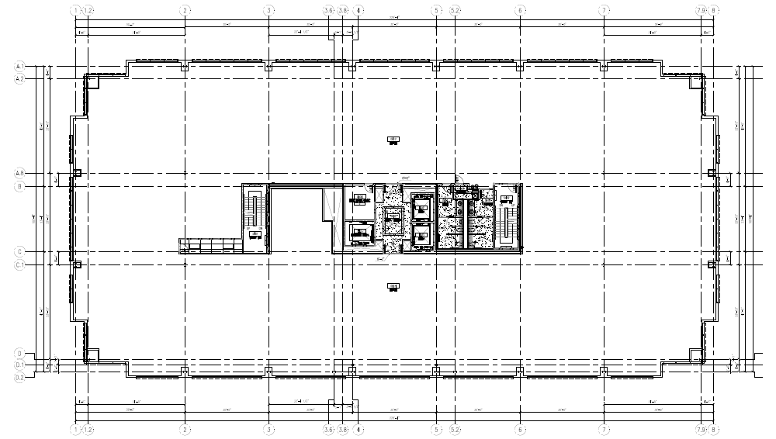

Floor System:

The second floor through the sixth floor are typical, therefore, the same floor system is used on each floor. This floor system consists of a composite lightweight concrete on steel deck combination. The deck is a VERCO W3 Formlock 20 gauge metal deck. The metal deck is filled with 3-1/4” light weight concrete fill with #3 bars at 18” O.C. each way. The beams are designed to support a maximum span of 11’-0”, and typical bays are 38’ x 30’ and 33’-10” x 34’-9”. Since the second floor through the sixth floor have identical floor plans, as well as beam, and girder sizes and applied loads, uniform floor systems are implemented throughout the building.

Figure 2: Typical Structural Floor Plan
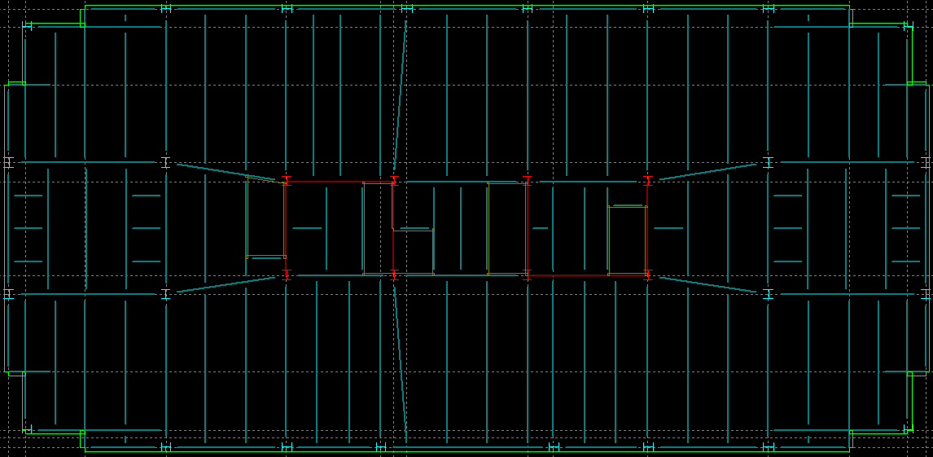

Figure 3: Decking Parallel to Beam

Foundation:

The foundation is a 5” thick slab on grade with #4 bars placed at 15”
O.C., and has a strength of 4000 psi. The slab is supported by grade
beams and spread footings. The grade beams are typically 48” x 48” and 4’-0” deep and require a minimum of 18” of finished floor above the beam. The spread footings which also have a strength of f’c = 4000 psi , range in size from 10’-6” SQ and a thickness of 24” to 19’-6” SQ with a thickness of 50”.

Figure 4: Foundation Plan

Columns:

Wide flange ASTM A992 GR 50 steel columns support the structure
and span 30.5’-0”, supporting two stories and are connected by 4’-0” splices between floors. Most columns at the ground level are supported by the grade beams. All columns have base plates made of ASTM A572 GR. 50 steel.

Lateral System:

The lateral force resisting system in Office Building B consists of a network of concentrically braced frames and moment frames that combine to make up a dual system. This lateral system frames into the grade beams in order to counteract the large uplift force associated with this type of system. The moment frames are located mainly along the perimeter of the structural framing system with the exception of two on the interior, while the concentrically braced frames are placed solely on the interior near the center of the building in such places as elevator shafts.

The moment frames are made up of W shapes ranging in size from W36’s on the second floor to W27’s on the roof level. The braced frames were also constructed using W shapes. These braced frames were designed to distribute lateral forces through triangles formed by the members, much in the same fashion that a truss distributes forces, and range in size from W12x156 to W24x76.

Proposal

Problem Statement

Because this current structure will be modeled as a prototype building to be designed in multiple locations, an investigation of the same structure located in Washington, D.C. will be done. This geographic location was chosen to investigate how the structure will respond in a low seismic zone, as well as to investigate security design options in a location that is at high risk for terrorist attacks.

The current lateral force resisting system, which is a dual system, brings into play a combination of concentrically braced frames and moment frames. Six braced frames and twelve moment frames make up the existing lateral force resisting system. According to ASCE 7-05, a dual system is not necessary unless the structure exceeds a total height of two hundred forty feet or more, thus making this design extremely conservative, even in a high seismic zone such as Ontario, CA. In addition to this, the cost of construction to properly fabricate moment connections in the moment frames is very high. For these reasons I intend to propose an altered lateral force resisting system.

The fact that the fully composite floor system is very efficient and integrates well with the steel braced frame design, the gravity load resisting system will not be altered in this case.

The proposed alternate design will be compared with the original design, and is intended to be a more cost efficient system, yet still be an adequate design to resist the lateral forces associated with wind and seismic loads.

Problem Solution

The solution that I plan to examine is one that utilizes only braced frames. To successfully design this system, the floor plans must be thoroughly examined as additional braced frames may need to be placed in other areas of the building without interrupting circulation paths.

Solution Method
The new lateral force resisting system will be designed to resist wind and seismic loads, as well as control drift and counteract torsion using the methods outlined in ASCE 7-05. After the seismic and wind forces are calculated they will be entered into a computer aided building model program, such as RAM or ETabs which will calculate the forces distributed to each member. Finally, a sufficient design, based on these forces will be determined.

Depth Analysis

Depth Analysis

Design References

The following were used to obtain design loads and design criteria for the proposed alternate lateral force resisting system:

ASCE 7 – 05
AISC LRFD, 3rd Edition

Lateral Loads

The wind and seismic loads resisted by the lateral force resisting system were calculated by the method specified in ASCE 7 – 05. When comparing the loads, it was found that the wind loading controlled over the seismic loading, as opposed to the previous case of the building located in southern California.

Table 1

WIND LOADS
 | LOADS (K) |  | SHEAR (K) |  | MOMENT (ft-k)
FLOOR | N/S | E/W | N/S | E/W | N/S | E/W
1 | 0 | 0 | 0 | 0 | 0 | 0
2 | 20.88 | 43.61 | 160.32 | 334.82 | 334.08 | 697.76
3 | 22.74 | 47.49 | 137.58 | 287.33 | 682.2 | 682.2
4 | 25.29 | 52.82 | 112.29 | 234.51 | 1112.76 | 2324.08
5 | 26.22 | 54.75 | 86.07 | 179.76 | 1520.76 | 3175.5
6 | 28.07 | 58.63 | 58 | 121.13 | 2021.04 | 4221.36
R | 34.79 | 72.66 | 29.23 | 61.05 | 2474.22 | 5166.88
PH | 29.23 | 61.05 | 0 | 0 | 2806.08 | 5860.8
TOTAL | 187.22 | 391.01 |  |  | 10951.14 | 22128.58

Depth Analysis – Lateral Design

This structural depth study consisted of altering the current dual system lateral force resisting system comprised of moment frames and concentrically braced frames. Because a dual system is not necessary unless the building height exceeds two hundred forty feet, this current system is a very conservative design, even for a high seismic region.

A concrete design would be more feasible for a low seismic region such as Washington, D.C., and the total building cost as compared to the steel design may be less, however the duration of the overall time to erect the building would be greatly increased. For this reason a steel design will be maintained to ensure rapid speed of construction.

The alternative design version of the steel lateral force resisting system that was investigated in the preliminary analysis was one with just braced frames. Due to the fact that it is expensive to properly weld moment connections in the field, it was decided that a system constructed solely of braced frames was the best alternative lateral system.

This study could have also been performed on the building located in southern California. Though California is a high seismic region, again the structure does not exceed two hundred forty feet in height and so a dual system is not needed. Switching to a concrete design would make the structure heavier, which wouldn’t react well under seismic loading. Again it appears that the best alternative is one consisting of braced frames. Some changes that would need to be made in order for the structure to handle the intense seismic loads would be the addition of possibly two more braced frames to counteract lateral forces in the X direction. Trying to find spaces to locate additional braced frames in this case is difficult. With the existing braced frames already carefully placed around the core of the building, this poses a problem for the reason that there are no load bearing walls in the interior spaces, and the façade contains a lot of glass windows. A possible solution would be to construct two eccentrically braced frames as opposed concentrically braced frames, and place them, again around the core. The fact that the frames would be eccentrically braced would allow flush placement around door openings without interrupting traffic flow and the open floor plan.

Figure 5: 3D Model of the building from RAM Structural

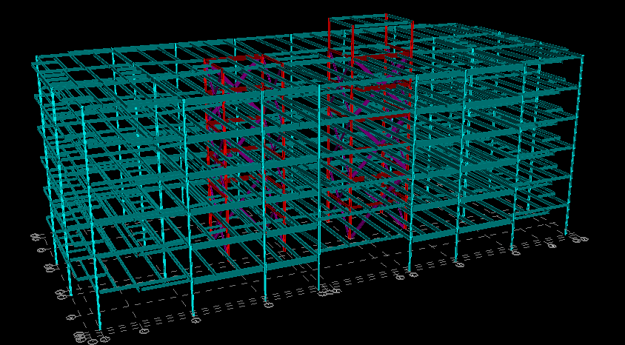

Three types of braced frame configurations could have been analyzed to resist the lateral loads for the structure, which are chevron, eccentric, and “X” frames. Eccentric bracing is more commonly used in seismic regions and allows for doorways and corridors. The difference between eccentric bracing and chevron or X bracing is the space between the bracing members at the top gusset connection. In an eccentrically braced frame members connect to separate points on the beam or girder. The beam/girder segment or link between bracing members absorbs energy from seismic activity through plastic deformation. Because this study is being done in Washington, D.C., eccentric frames are not necessary. Both chevron and X frames are both different configurations of concentrically braced frames, thus either configuration could have been analyzed. Since the X frames worked well for the original design, it was decided that this configuration would be analyzed for the re-design as well.

The first step in redesigning the alternative lateral system was modeling the individual frames in the computer modeling program RAM Advanse. This was done by isolating the frames for both the X and Y directions, and then applying the calculated gravity loads and lateral forces on the fames. RAM Advanse then analyzed the structure and sized the members of the frames to accommodate for the worst case scenario load combinations listed in ASCE 7 -02. These preliminary brace member sizes were then checked with hand calculations by the methods outlined in the Manual of Steel Construction, AISC LRFD, 3rd Edition. The controlling load combinations can be found in the chart below.

Controlling Load Combinations
 | Columns | Beams | X Members
Y Direction Frames | 1.2 D +/- 1.3 W | 1.4 D or (1.2D - 1.3 W) | 1.2 D +/- 1.3 W
X Direction Frames | 1.2D + 1.6L | 1.2 D + 1.6L | (1.2D +/- E+L) or (1.2D + 1.6L)

The next step in the process was building a model of the entire structure in RAM Structural. The gravity beams and columns remained the same sizes since the gravity loads remained unchanged. The brace member sizes that were previously calculated by RAM Advanse were then assigned to the braces in the building model in RAM Structural. Next, the frames were analyzed to ensure that the design of all braced frames complied with a drift limit of H/400 (an industry standard), in which H is equal to the total height of the braced frames. This drift limit for all braced frames for all ASCE 7 – 02 loading conditions was calculated to be 2.88 inches, however the maximum building drift came out to be 4.68 inches. In order to conform to the drift standard of H/400 additional braced frames may need to be added, or an increase in member sizes of the existing braced frames may be needed.

Figure 5: 3D Model isolating the frames

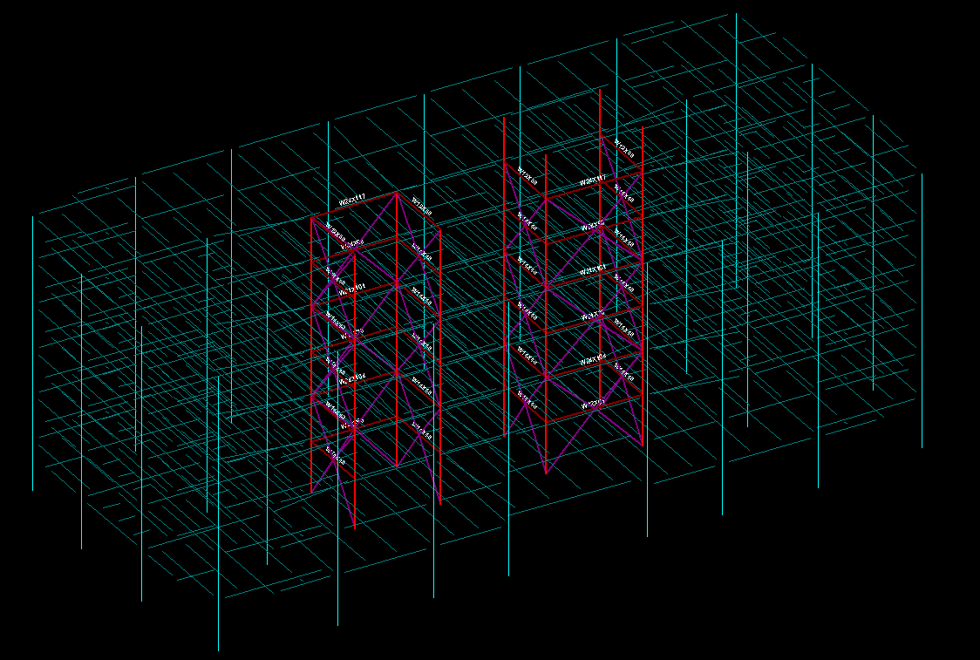

Figure 6: The deflected shape of the frames (scale factor 100)

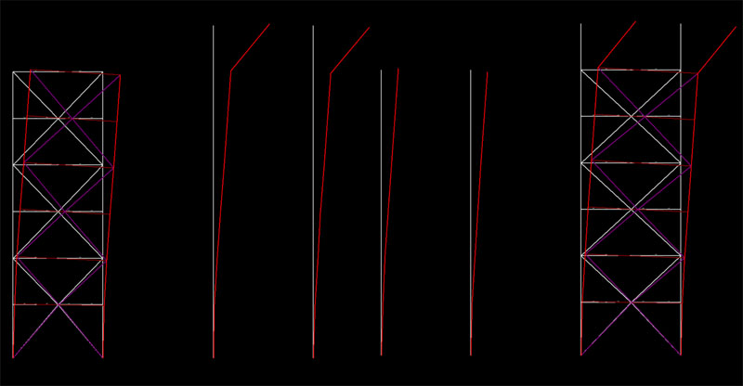

Structural Depth Conclusion

After analyzing the braces for the drift limit and lateral forces, the actual drift limit for this building was calculated to be 4.68 inches, which is more than the industry standard of H/400. Additionally, RAM Structural was used to find the maximum story drift which was 0.96 inches. Since this is a serviceability issue and not a strength issue, this design may work, however, occupants may complain they are uncomfortable due to the building drift and additional braced frames may need to be added or the member sizes of the existing braced frames may need to be increased. It was assumed that because the building is symmetric, and the braced frames are placed symmetrically the structure will not experience any significant torsion effects. A figure of the braced frames labeled with the member sizes can be found in Appendix A.

Architectural Breadth

Architectural Breadth

Problem Statement

The tragic events of September 11, 2001 left the nation shocked and angry. These events, however, also re-invented the way structural engineers plan and design buildings. The fact that this building is located in the heart of Washington, D.C. makes it a prime target for acts of terror.

Solution Process

The strategies and technology used to prevent terrorist attacks used by engineers in practice was thoroughly researched by reading handbooks and articles, as well as contacting design professionals. After the research was done, a close examination of the site plan was performed to see what improvements could be made.

Blast loads or intentional impact events with extreme severity are loads that do not occur frequently but they have extraordinary consequences. Designers may now be required to consider loads previously thought rare and improbable. When designing a building to resist blast and impact loads, the design is usually thought of in terms of life safety, not in the context of serviceability or life cycle performance, except for structures such as nuclear reactors and explosive test facilities. These cases may require serviceability and reuse, while most structures such as office buildings and residence towers will not have to perform to these levels. Such structures designed to resist these blast and impact loads may be designed to fail locally to prevent the entire structure from failing.

As stated by AISC’s Facts For Steel Buildings, Blast and Progressive Collapse, there are three types of actions that can cause these types of blast impact loads. They are explosions, detonations and deflagrations. An explosion is a rapid release of stored potential energy characterized by a bright flash and an audible blast. Part of the energy is released as thermal radiation and part is released into the air as airblast and into the soil as ground shock. To be an explosive, the material must posses the following:

- contain a substance or mixture of substances that remains unchanged under ordinary conditions, but undergoes a fast chemical change upon stimulation

- produce a reaction that yields gases whose volume is much greater than the original substance

- produce a change that is exothermic in order to heat the products of the reaction and increase their pressure.

A detonation occurs when all stored potential energy is released in the chemical reaction of the source material. Velocities in the combustion below this detonation velocity will result in a reaction called a deflagration, where only a portion of the stored potential energy is released in the chemical reaction. The class of explosion is usually determined by the initiation energy available. The initiation energy is usually delivered as a strong shock provided by impact.

Some examples of explosive sources include the following:

- bursts of pressure vessels with inert , flammable, and detonable gases

- deflagration and detonation of dusts and particulates

- accidentally or intentionally released flammable or detonable gases in semi - confined and unconfined spaces

- improvised explosive devices consisting of agricultural fertilizer and diesel fuel, black powder devices and modified military weapons

- a large variety of commercial and military explosives.

The structure should be deigned to resist shock waves. When there is an obstruction in the wave’s path, such as a wall, the blast waves will reflect to amplitudes many times their value. Again referring to AISC’s Facts For Steel Buildings, Blast and Progressive Collapse, when subjected to the shock, the building can respond in several ways depending on the strength of the blast and the duration of the wave. The duration of a typical blast force is usually a small fraction of the natural period of a building, so these loads typically don’t have much significant impact on the overall lateral force resisting system of a structure. The frequencies of individual elements of the overall system are often in the same period range, and severe local damage may be imposed on individual elements, which can lead to further instability of the entire structure. If the structure is in a very strong blast wave region, it may respond locally with shattering, shearing and tearing of the structural material. This is known as the “brisance effect”, which is a very high pressure effect of the explosive. If the structure experiences a more uniform pressure, it will respond traditionally. Ductility is important in either case. The ideal structural response to a blast is one in which elements deform and absorb or use up energy prior to fracture or failure. The goal of blast resistant design is to prevent the collapse of the structural system and maintain structural integrity through ductile behavior. Another primary goal is to reduce debris which is a major cause of injuries and fatalities in explosions.

The smartest way to defend the building is with perimeter security and site planning. Defining what the possible threats to the building are is also essential. AISC states that there are two types of deliberate attacks using blast loads are generally considered. They are bomb attack and person-carried explosive attack. Vehicle bomb attacks historically have ranged in size from tens of pounds of explosives to tens of thousands of pounds. Vehicle bomb attacks are limited by vehicle access and approach points. Enforced standoff between the nearest desired approach of unrestricted vehicles must be provided. Since traffic laws and street curbs and lawns will not stand in the way of terrorists, vehicle barrier designs and products are available to help make perimeters undisturbed. Person-carried explosive devices are generally considered to be less than 100 pounds, and are usually assumed to be approximately 50 pounds. Buildings may also be threatened because of their proximity to buildings of higher target value. In the case of The World Trade Center in New York City, numerous nearby structures failed or experienced significant structural damage that resulted from the failure of the towers.

Joe Valancius, S.E. of Wiss, Janney, Elstner Associates Inc., says that the best solution is standoff distance. The farther from the building you can keep an explosive charge, the better. This can be accomplished through site planning and vehicle access restrictions. Vehicles can be screened at some distance away from the building and visitor parking can be restricted to lots far away from the building. Vehicle height restriction devices and other barricade devices can be used to keep larger potential vehicle bombs farther away. Additionally, delivery areas, such as loading docks, should be placed at locations such that if a delivery truck brings in a package bomb the impacts on the building are minimized. Thus, a separate structure for receiving and sorting packages would be best.

Architectural Breadth Conclusions

After reviewing the information obtained through research about blast design, a thorough analysis of the site plan was performed. Several adjustments were made in order to eliminate possible threats, and make the site less susceptible to blast attacks.

The first adjustment made was the elimination of an entry to the site from the main road. By reducing the number of entryways to the site, the chance of vehicles carrying bombs and going unnoticed is reduced.

Next, the edition of security checkpoint booths at both of the entry points was added. These booths will be occupied by professionally trained security officers. Also, these booths will be electronically automated to allow workers and frequent visitors to pass through by sliding their card into a machine. Once delivery and mail trucks are granted access to the site, they will only be allowed to drop off deliveries at the designated loading dock that was added in place of the parking lot located next to building A. Elimination of this parking lot increases the standoff distance mentioned above, while the loading dock was purposely built independently of the rest of the buildings. In the event that a blast does occur by means of a delivery, the rest of the buildings on the site are at much lower risk due to the fact that the loading dock is an independent structure.

Furthermore, parking spaces adjacent to building B were eliminated again, to maintain a safe standoff distance. The only spaces that remained were handicap parking spaces. The parking spaces located next to building C and on the far side of the access road remained unchanged because of their distance from the buildings.

Lastly, the addition of concrete posts three feet in height were added along the access road to prevent vehicles from entering the walkways between buildings. The comparison of the site plans can be seen in the Appendix B.

Construction Management Breadth

Construction Management Breadth

Problem Statement

When comparing the lateral force resisting system designed for this structure in California with that of the proposed system for the same structure in Washington, D.C., the expected outcome is that a significant amount of money and labor hours will be saved. In order to compare the systems and get results, a cost analysis was performed using RSMeans Building Construction Cost Data.

Solution Process

The first step in the solution process was obtaining the price of fabricating moment connections and the price of fabricating shear connections. Next, the reduction of member sizes where the moment frames previously existed were accounted for in cost savings and time savings. Since the gravity loads and gravity systems remained unchanged between the original system and the proposed system, it was not necessary to include the cost comparison of the gravity systems. The shear connection and moment connection prices were obtained by contacting industry members and referring to RSMeans 2006. Once prices were obtained, the overall costs of labor, materials, and fabrication were compared to determine the overall savings. Following this step, the total man hours saved for scheduling purposes were calculated.

Comparison

The component of the existing lateral system being analyzed is the moment connection needed to properly fabricate moment frames. The prices of the moment connections will then be compared to the prices of shear connections, which include linear feet of weld, labor costs, labor hours, equipment, materials and finally the duration of constructing both types of connections. The numbers for both components were totaled in linear feet or quantity for welds, and then multiplied by the RSMeans unit costs to produce a total cost for both types of connections. The total cost for the entire existing moment connection system and shear connection system was then calculated. As a result, the total estimated cost for the moment connections is $191, 602.00, while the shear connections needed to fabricate the gravity system came to a total of $75, 906.00. This is equal to a total savings of $115, 695.00, or a savings percentage of 65.6%. Next the time on labor hours was calculated. With the aid of RSMeans, it was estimated that both an E6 and an E9 crew would be needed to erect the steel superstructure in both southern California and Washington, D.C. The total number of man hours saved by eliminating moment frames was calculated to be 947.83. With an E6 and E9 crew producing 265 man hours per day, this will save 3.7 or about 4 days in steel erection which is on the critical path. A cost comparison table can be viewed on the following page.

Table 2: Cost comparison chart
Moment Connection Vs. Shear Connection Cost
Moment Connection
Description | Quantity L.F. | Labor Cost | Labor Hours/L.F. | Equip. | Material | Total | Total Incl. O&P | Duration Hrs
Interior Connections (per column)
Web (1/4" Weld) | 15.3 | $183.60 | 0.21 | $33.20 | $7.50 | $224.30 | $361.12 | 3.2283
Flange (5/16" Weld) | 17.7 | $280.19 | 0.21 | $50.56 | $11.72 | $342.47 | $551.37 | 3.7347
Exterior Connections (per column)
Web (1/4" Weld) | 11.5 | $138.00 | 0.21 | $24.96 | $5.63 | $168.59 | $271.43 | 2.4265
Flange (5/16" Weld) | 13.25 | $209.75 | 0.21 | $37.85 | $8.77 | $256.37 | $412.76 | 2.79575
Total Per Floor | 1155 | $16,230.80 | 0.21 | $2,931.40 | $672.40 | $19,834.60 | $31,933.60 | 243.705
Total for 6 Floors | 6930 | $97,384.80 | 0.21 | ######## | $4,034.40 | ######### | $191,601.60 | 1462.23
Shear Connection
Description | Quantity L.F. | Labor | Labor Hours | Equip. | Material | Total | Total Incl. O&P
Interior Connections (per column)
Web (1/4" Weld) | 15.3 | $183.60 | 0.16 | $33.20 | $7.50 | $224.30 | $361.12 | 2.448
Exterior Connections (per column)
Web (1/4" Weld) | 11.5 | $138.00 | 0.16 | $24.96 | $5.63 | $168.59 | $271.43 | 1.84
Total Per Floor | 536 | $6,432.00 | 0.16 | $1,163.20 | $262.60 | $7,857.80 | $12,651.00 | 85.76
Total for 6 Floors | 3215 | $38,592.00 | 0.16 | $6,979.20 | $1,575.60 | $47,146.80 | $75,906.00 | 514.4
Total Savings w/ Shear Connections |  |  |  |  |  |  | $115,695.60 | 947.83

The next part of the cost analysis was calculating the savings in the reduction of member sizes when changing the moment frames to part of the gravity system. All new gravity columns and beams were designed in RAM Structural. The column and beam sizes of the moment frames were compared to the new gravity columns and beams that will replace the moment frames. This was done by calculating the total length of each member size the makes up the moment frames as compared to the gravity members, which was multiplied by the member weight and then multiplied by the price per pound of steel (which was obtained from RSMeans 2002) to acquire the cost. The total cost savings in beam sizes was found to be $359,765, while savings in column sizes came to be $690,460. This is equivalent to a total cost reduction from member sizes of $1,050,230.

GRAVITY BEAMS
 | Size | Length | Weight (lbs) | Price/lb | Total Cost
Original Design
 | W33X169 | 127 | 72163 | 1.15 | 82987.45
 | W33X152 | 213.5 | 32452 | 1.15 | 37319.8
 | W33X141 | 213.5 | 30103.5 | 1.15 | 34619.03
 | W27X146 | 427 | 62342 | 1.15 | 71693.3
 | W36X359 | 262.648 | 94290.6 | 1.15 | 108434.2
 | W30X326 | 131.324 | 42811.6 | 1.15 | 49233.34
 | W30X292 | 131.324 | 38346.6 | 1.15 | 44098.59
 | W27X258 | 131.324 | 33881.6 | 1.15 | 38963.84
 | W27X161 | 131.324 | 21143.2 | 1.15 | 24314.68
Total |  |  |  |  | 491664.2
New Design
 | W24X68 | 600 | 40800 | 1.15 | 46920
 | W24X55 | 467.5 | 25712.5 | 1.15 | 29569.38
 | W27X84 | 120 | 10080 | 1.15 | 11592
 | W24X62 | 93.5 | 5797 | 1.15 | 6666.55
 | W18X40 | 656.62 | 26265 | 1.15 | 30204.75
 | W18X46 | 131.324 | 6040.9 | 1.15 | 6947.035
Total |  |  |  |  | 131899.7

GRAVITY COLUMNS
 | Size | Length | Weight (lbs) | Price/lb | Total Cost
Original Design
 | W14X342 | 456 | 155952 | 1.15 | 179344.8
 | W14X283 | 760 | 215080 | 1.15 | 247342
 | W14X233 | 456 | 106248 | 1.15 | 122185.2
 | W14X398 | 304 | 120992 | 1.15 | 139140.8
 | W14X342 | 304 | 103968 | 1.15 | 119563.2
 | W14X283 | 304 | 86032 | 1.15 | 98936.8
Total |  |  |  |  | 906512.8
New Design
 | W12X120 | 304 | 36480 | 1.15 | 41952
 | W12X72 | 608 | 43776 | 1.15 | 50342.4
 | W12X106 | 152 | 16112 | 1.15 | 18528.8
 | W12X87 | 304 | 26448 | 1.15 | 30415.2
 | W12X120 | 152 | 18240 | 1.15 | 20976
 | W12X72 | 152 | 10944 | 1.15 | 12585.6
 | W12X62 | 304 | 19760 | 1.15 | 22724
 | W12X53 | 304 | 16112 | 1.15 | 18528.8
Total |  |  |  |  | 216052.8

Conclusion

With a savings in the cost of connections of $115, 695.00, and a savings in member sizes of $1,050, 230 this proves to be a good solution and that the expected results of saving money were obtained. The total man hours that were saved will also be an additional saving in costs since it will take about four days less to erect the steel frame for the structure in Washington, D.C. as opposed to the original structure in Ontario, CA.

Final Conclusions

Final Conclusions

This concludes the year long study of Office Building B. The purpose of this thesis study was to research an alternate structural system that could perhaps be more efficient than the existing dual system lateral force resisting system for the same structure located in Washington, D.C., and compare it with the original building in Ontario, CA in terms of cost and schedule. The alternate structural system that was proposed was a lateral system which contained only braced frames. This study was carried out with the aid of computer programs such as RAM Structural and RAM Advanse, which provided preliminary sizes of members, and calculated drift effects.

The second study done was one of the preventative measures that can be taken to reduce threats of terror attacks, and how to minimize damage if and when they occur. Since the comparison location is Washington, D.C., this makes the building a prime target for terrorist attacks. With more research being conducted in this area than ever before, it may soon be required by code to structurally and architecturally design buildings to withstand these types of loads.

In order to prove the expected outcome of a savings in cost and reduction in schedule time due to the removal of the moment frames from the lateral system, a cost analysis and study of labor hours was done by referencing RSMeans 2006 Building Construction Cost Data. There was, in fact a savings in cost and man hours. The total cost savings equaled $1,165,930. The total number of days saved from the erection of the steel structure which is in the critical path were four.

References

- AISC, Manual of Steel Construction, Load and Resistance Factor Design (LRFD), 3rd Edition

- ASCE 7 – 05, Minimum Design Loads for Buildings and Other Structures

- AISC, Facts for Steel Buildings, Blast and Progressive Collapse

- RSMeans 2006 Building Construction Cost Data

Appendix A
Member sizes for frames in the X -direction
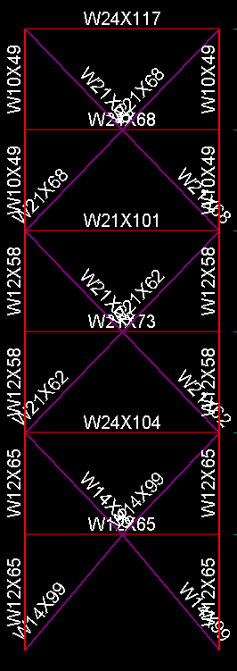

Member sizes for frames in the Y -direction
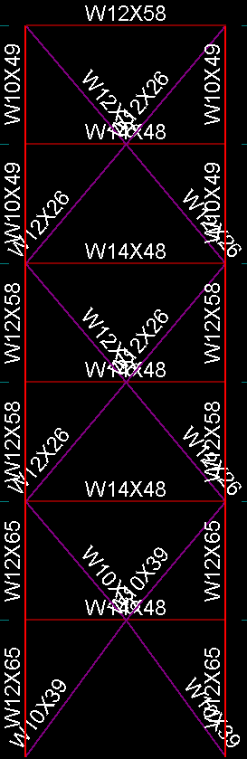

Appendix B
Existing Site plan

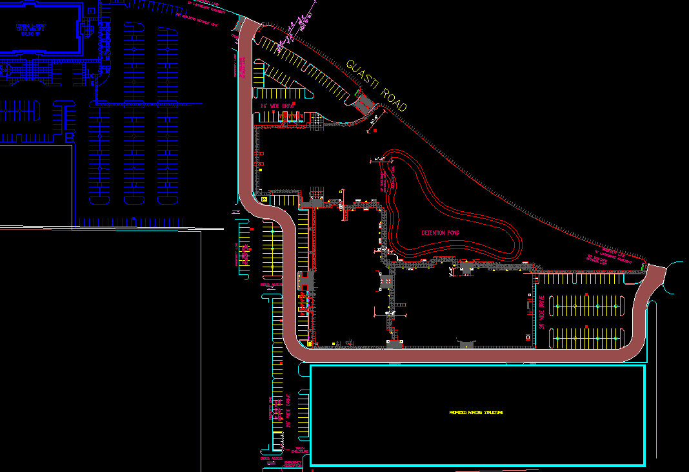

Appendix B
Site Plan With Security Design Measures

